Welcome to Your Online Course
<<Click here to enter your School Name>> and Edgenuity are committed to your intellectual growth and achievement. To honor our commitment to you, this online course contains best-in-class instruction taught by highly qualified educators, self-check practice activities, graded and written assignments, as well as a variety of assessments; all have been designed to help you master this course.

Course Requirements
Online learning requires a level of responsibility from you that can help you be successful, which includes:
- Being prepared and ready to learn before you start your online coursework
- Staying on track by completing the assigned work every day
- Taking notes (written or electronic) as you listen to the instructional activities
- Comprehending online reading selections
- Composing thoughtful, well-written responses with minimal spelling and grammatical errors
- Asking for help when you have questions or misunderstandings
- Studying before your assessments
- Tracking your progress and grades
- Treating others in this course, classroom, or lab with the same respect you expect

Academic Integrity
Integrity is doing the right thing, even when no one is watching.
C. S. Lewis
You should always have pride in the work you do and should take ownership in your own learning! We understand that with tools like Google search, it’s easy to find immediate answers to your questions. In this class, you are responsible for understanding the difference between using the web for help and support of your learning, versus using the web to cheat. Cheating is against our classroom policy and has consequences.

Student Expectations in this Course
Academic dishonesty jeopardizes your success and your integrity. In completing this online coursework, you agree to:
- Be honest at all times
- Actively encourage academic integrity in your classmates
- Discourage any forms of cheating or dishonesty
- Inform your teacher, counselor, administrator, or someone you trust if you have a reasonable belief and/or evidence that academic dishonesty has occurred
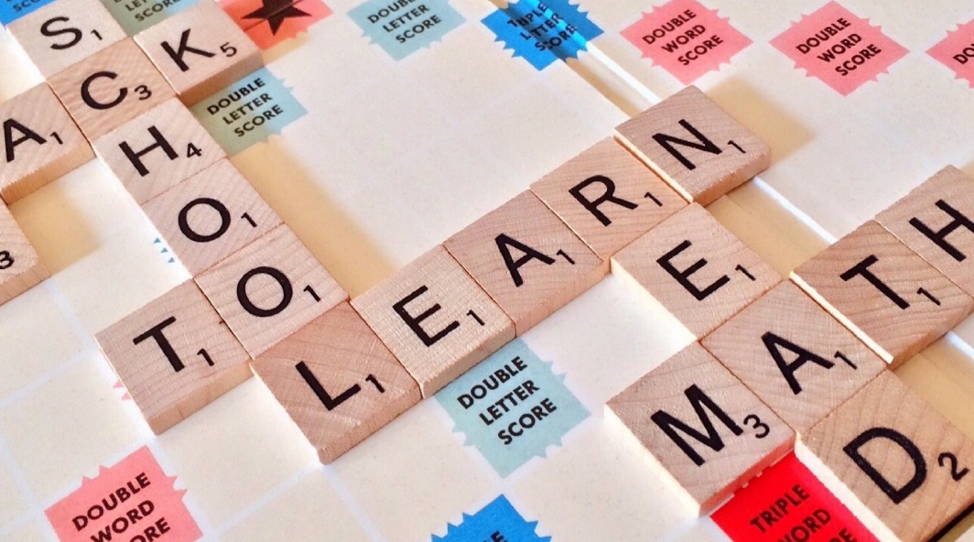
Some examples of academic dishonesty are, but not limited to:
- Using unauthorized materials and/or resources throughout this course
- Copying work from another student, or from the web
- Using a technological/communication tool and/or resource during an assessment
- Having anyone else but you complete any part of your coursework for you
- Using online searches to find answers to your assessment questions
- Posting answers to assessment questions online

Academic Dishonesty Consequences
Click here to add your classroom policies for violating this honor code.

Teacher: |  | Student:
Date: |  | Date:

