Evidence of Effectiveness
Edgenuity’s suite of research-based online courses are generating positive student outcomes across the country. Below is a summary of efficacy research for Edgenuity solutions.

Table of Contents
Courseware® 6–12 2
Altamont High School, Utah (Level 4) 2
Appleton Central High School, Wisconsin (Level 4) 2
Bald Eagle High School, Pennsylvania (Level 4) 3
Classical Academies, California (Level 4) 3
Copper River School District, Alaska (Level 4) 4
Cypress-Fairbanks Independent School District, Texas (Level 2) 5
Dearborn Public Schools, Michigan (Level 4) 5
Dickinson Independent School District, Texas (Level 4) 5
Graduation Solutions, LLC, Arizona (Level 3) 6
Houston Independent School District, Texas (Level 4) 6
Locust Grove Middle School, Georgia (Level 3) 7
Pasadena Independent School District, Texas (Level 4) 8
Putnam County Schools, Tennessee (Level 4) 8
Rio Rancho Cyber Academy, New Mexico (Level 4) 8
Success Virtual Learning Centers, Michigan (Level 4) 9
Taos Academy Charter School, New Mexico (Level 4) 10
Utah Online, Utah (Level 4) 10
Vertus High School, New York (Level 4) 11
Village Green Virtual Charter School, Rhode Island (Level 4) 11
Windsor High School, Connecticut (Level 4) 13

Courseware® 6–12

Altamont High School, Utah (Level 4)
In fall 2014, Altamont High School (AHS) set out to improve math achievement after 87 percent of high school students scored below the proficient level on the spring 2014 Student Assessment of Growth and Excellence (SAGE) math assessment. In fall 2015, the school enrolled all 200 of its high school students in Edgenuity online math courses. Students spent 70 minutes per day in the computer lab working on these courses. Edgenuity examined the SAGE math performance of AHS 9th, 10th, and 11th grade students enrolled in Edgenuity online math courses. Data show that across all grade levels, the percentage of AHS students achieving proficiency on the SAGE math assessment increased from 2014 to 2017. Results were particularly impressive for 10th grade students, who demonstrated more than an eightfold increase in the percentage of students scoring at or above the proficient level.

Figure 1. Altamont High School Edgenuity Students, Grades 9–11
Percentage of Students Reaching Proficiency on Spring 2014, 2015, 2016, and 2017 SAGE Math

Appleton Central High School, Wisconsin (Level 4)
Most students at Appleton Central High School (ACHS) are significantly credit deficient due to a range of factors, including teen pregnancy, mental health concerns, academic delays, alcohol and drug abuse, criminal behavior, and poverty. ACHS also enrolls withdrawn and expelled students. Most entering students are at least 1.5 years behind grade level. Edgenuity courses are used at ACHS for the Central Day, General Educational Development Option #2 (GEDO#2), and Dan Spalding Academy (DSA) programs. Central Day students attended school three hours a day, five day a week. Depending on the semester and required courses, students generally completed at least one course using Edgenuity’s math, language arts, science, social studies, and elective credit recovery courses in a computer lab during a 38-minute period. Students over the age of 17 used Edgenuity to complete some of the requirements needed for entry into the GEDO#2. Additionally, students enrolled in DSA used Edgenuity’s initial-credit core and elective courses to advance in their coursework while under expulsion.

After one year of implementing Edgenuity courses along with other academic and social interventions, the four-year graduation rate of students in this program for at-risk students increased from 16 percent to 46 percent. The dropout rate declined from 14 percent to 9 percent.
Figure 2. Appleton Central High School Figure 3. Appleton Central High School
Graduation Rate Dropout Rate

Bald Eagle High School, Pennsylvania (Level 4)
From September 2, 2015, to January 22, 2016, 40 students who needed to retake the biology Keystone Exam were offered Edgenuity’s Biology Virtual Tutor (an online test preparation program) 44 minutes per day, five days per week. After using Edgenuity’s Biology Virtual Tutor for 18 weeks, students showed gains on the biology Keystone Exam. On Module 1, Edgenuity students demonstrated significant improvement from a spring 2015 scale score of 1,471 to a winter 2016 scale score of 1,492, a 21-point gain (p<0.05). On Module 2, Edgenuity students demonstrated significant improvement (p ≤ 0.05 per a dependent t-test) from a spring 2015 scale score of 1,477 to a winter 2016 scale score of 1,481 (a 4-point gain).

Figure 4. Bald Eagle High School Edgenuity Students, Grades 10–11
Performance on the Pennsylvania Biology Keystone Exam, Spring 2015 to Winter 2016 (N = 40)

Classical Academies, California (Level 4)
In 2013, Classical Academies set out to provide more flexible learning options that would better differentiate instruction and create more time for conferencing with students and parents. A collaborative leadership team made up of department heads, teachers, principals, parents, and school board members began researching online curriculum providers to support this initiative. Classical Academies chose Edgenuity because of its research base, breadth of course offerings, and actionable data.

Data showed that 81 percent of students earned a score of three or higher on their Advanced Placement tests and 99 percent of students graduated on time.

Student engagement continues to rise as students find a comfortable and safe learning environment, as well as quality college prep courses through Edgenuity. Students who have struggled with a traditional public school setting are now successful in this environment. Edgenuity has provided the students and the staff with an ideal learning partnership, where students are able to accelerate, are held accountable, and are motivated to have a successful learning experience.

Copper River School District, Alaska (Level 4)
In fall 2013, Copper River School District implemented Edgenuity as a curriculum resource (used in a rotational model) with middle and high school students. During the 2013–2014 school year, Edgenuity examined the impact of Edgenuity Courseware on the reading and math achievement of Copper River middle and high school students. NWEA MAP Growth assessment data were obtained for 130 reading students and 126 math students, and a normative comparison group of 6th through 11th grade students who did not use the program. After one year, students reduced the achievement gap that existed between themselves and the national norm on the reading and math RIT scales. For example, Edgenuity 6th, 7th, 8th, and 9th graders significantly gained 8.7, 8.4, 8.4, and 4.8 points, respectively. Perhaps more notably, while 7th grade students were performing 2.8 points below the national norm in fall 2013, by spring 2014 they were performing above it.

Figure 5. Copper River School District Edgenuity Students, Grades 6–11 (N = 130)
Performance on the NWEA MAP Growth Reading Assessment, Fall 2013 to Spring 2014
Grade | N | Fall RIT 2013 | Spring RIT 2014 | RIT Gain | Gap to National Norm Reduced by...
6th | 24 | 200.7 | 212.9 | 12.3* | 8.1
7th | 18 | 208.3 | 212.7 | 4.3 | 1.0
8th | 23 | 210.4 | 219.0 | 8.6* | 5.5
9th | 29 | 225.8 | 229.8 | 4.0* | **
10th | 15 | 228.1 | 230.7 | 2.7 | **
11th | 21 | 231.2 | 234.5 | 3.3 | **
All Grades | 130 | 217.2 | 223.3 | 6.1* | N/A
*p<0.05 ** Already performing above national norm

Figure 6. Copper River School District Edgenuity Students, Grades 6–11 (N = 126)
Performance on the NWEA MAP Growth Math Assessment, Fall 2013 to Spring 2014
Grade | N | Fall RIT 2013 | Spring RIT 2014 | RIT Gain | Gap to National Norm Reduced by...
6th | 24 | 214.6 | 223.3 | 8.7* | 2.7
7th | 18 | 222.8 | 231.2 | 8.4* | **
8th | 22 | 2257 | 234.1 | 8.4* | 4.1
9th | 26 | 241.4 | 246.3 | 4.8* | **
10th | 18 | 238.8 | 243.2 | 4.4 | **
11th | 18 | 250.1 | 251.8 | 1.8 | **
All Grades | 126 | 231.8 | 238.0 | 6.2* | N/A
*p<0.05 ** Already performing above national norm

Cypress-Fairbanks Independent School District, Texas (Level 2)
During the 2015, 2016, and 2017 school years, Cypress-Fairbanks Independent School District (CFISD) students who passed the State of Texas Assessment of Academic Readiness (STAAR) End-of-Course (EOC) assessment, but failed the corresponding course in English I, English II, Algebra I, U.S. History, or Biology, were given the option to retake the failed course in a traditional credit recovery classroom or using an Edgenuity online credit recovery course. Across all subjects and years, results show that students enrolled in Edgenuity’s online English I, English II, Algebra I, U.S. History, and Biology courses obtained more credits (99.7 percent versus 73.8 percent) and achieved higher course grades (79.6 percent versus 64.5 percent) than an equivalent group of students enrolled in a face-to-face credit recovery course.

Figure 7. CFISD Students, Treatment and Comparison Groups (N = 1,962)
Course Grade and Credit Attainment Rates, School Year 2015–16 to School Year 2017–18
Subject | Treatment Group |  |  |  |  |  | Comparison Group
 | # Students | # Enrollments | Avg. Grade | # Credits Attempted | % Credits Earned | # Students |  | # Enrollments | Avg. Grade | # Credits Attempted | % Credits Earned
Algebra I | 128 | 136 | 77.0%*** | 68 | 99.3%* | 128 |  | 185 | 65.9%*** | 92.5 | 69.7%*
English I | 127 | 134 | 80.3%*** | 67 | 100.0%* | 127 |  | 151 | 62.4%*** | 75.5 | 68.2%*
English II | 207 | 220 | 79.1%*** | 110 | 100.0%*** | 207 |  | 255 | 65.2%*** | 127.5 | 76.9%***
Biology | 215 | 222 | 79.5%*** | 111 | 100.0%** | 215 |  | 282 | 62.4%*** | 141 | 70.6%**
U.S. History | 304 | 317 | 82.2%*** | 158.5 | 99.4%* | 304 |  | 406 | 66.5%*** | 203 | 78.1%*
All Subjects | 981 | 1,029 | 80.0%*** | 514.5 | 99.7%*** | 981 |  | 1,279 | 64.6%*** | 639.5 | 73.5%***
*p<0.05; **p<0.01; ***p<0.001
Note: Students earned 0.5 credits for a semester-long course and one credit for a year-long course.

Dearborn Public Schools, Michigan (Level 4)
In fall 2009 Dearborn Magnet High School began using Edgenuity with some of its most challenged, at-risk students. Data showed that four years since the implementation of Edgenuity, graduation rates for the students served by the school have nearly quadrupled: 21 percent in 2009 to 80 percent in 2014.

Figure 8. Dearborn Magnet High School
Five-Year Graduation Rate, 2009 to 2014

Dickinson Independent School District, Texas (Level 4)
During Summer 2017 and Summer 2018, Dickinson Independent School District offered online Edgenuity biology and U.S. history courses to a small group of students for whom the traditional high-school setting was not working. Results showed that students who used Edgenuity courses demonstrated significant growth on the biology STAAR EOC assessments from their first attempt to most recent attempt.

Figure 9: Dickinson Independent School District, Texas
Performance on the US History and Biology STAAR EOC Tests
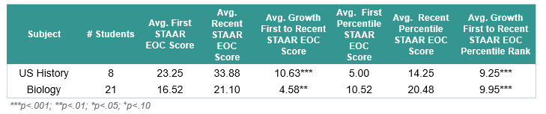

Graduation Solutions, LLC, Arizona (Level 3)
Graduation Solutions, LLC, is an online dropout recovery program that enrolls about 1,800 students across the state of Arizona. Open to students ages 16 to 21, the program is designed to offer students who have been disengaged from high school for at least 30 days a chance to earn a diploma. The school uses Edgenuity online courseware for its entire curriculum delivery system.

Data from 2017 to 2018 show that Edgenuity Courseware is having a positive influence on student graduation rates. For example, every additional Edgenuity mathematics and reading course taken increased the odds of a student graduating by more than 1.12.

Data also show a strong relationship between Edgenuity Courseware and the AzMERIT state test.
- For every additional hour spent in Courseware, there was a 0.66-point increase in AzMERIT ELA scores.
- For every additional 1 percent course progress, there was a 1.37-point increase in AzMERIT Algebra 1 scores.
- For every additional 1 percent course progress, there was a 0.56-point increase in AzMERIT Algebra 2 scores.
- For every additional 1 percent per day course progress, there was a 7.93-point increase in AzMERIT Geometry scores.
Additionally, 447 students graduated from Graduation Solutions with a high school diploma, setting them up for success in their next step, whether academically or professionally.

Houston Independent School District, Texas (Level 4)
From 2013 to 2016, the Greater Houston Community Foundation and Houston Independent School District (HISD) launched the Learn Engage Advance Persevere (LEAP) program to address the needs of middle school students most at risk of dropping out of school. As part of this program, Edgenuity online courses were offered to overage 6th, 7th, and 8th grade students at Edison and Jackson Middle Schools who needed targeted intervention support. An independent research firm, Safal Partners, studied changes in STAAR reading and math test scores and discipline by Edgenuity users during the 2013, 2014, and 2015 school years. When data were collected from students who took the spring STAAR reading and math tests in 2014 and 2016, results showed that the percentage of students performing at the Satisfactory Performance Level nearly doubled (from 18 percent to 34 percent). Findings also showed that two years of Edgenuity use contributed to improved behavioral outcomes. In 2014, 22 percent of Edgenuity students were suspended for six or more days, but by 2016, this figure dropped to 12 percent.
Figure 10. Houston Independent School District Edgenuity Students, Grades 6–8 (N = 250)
Percentage of Students Achieving Satisfactory Performance Level on STAAR Reading and Math Tests, 2014 and 2016

Locust Grove Middle School, Georgia (Level 3)
During the 2013–2014 school year, Locust Grove Middle School was one of six schools in Henry County to pilot Courseware as part of its new blended learning initiative. 2014 Criterion-Referenced Competency Tests (CRCT) in English language arts, mathematics, reading, social studies, and science data were obtained from 94 7th grade students who used Edgenuity Courseware and a matched comparison group of 195 7th grade students who did not use the program. After one year, Edgenuity online participants demonstrated significantly higher scores (p < 0.05) on the 2014 CRCT than students in the matched comparison group of nonparticipants.

Figure 11. Locust Grove Middle School Edgenuity Students and Comparison Group, Grade 7
Percentage of Students Meeting or Exceeding the Standard on CRCT, 2014*

*Note: Sample sizes are as follows: Edgenuity Students (N = 94); Non-Edgenuity Students, Language Arts (N = 183); Non-Edgenuity Students, Mathematics (N = 181); Non-Edgenuity Students, Reading (N = 183); Non-Edgenuity Students, Science (N = 195); Non-Edgenuity Students, Social Studies (N = 195).

Pasadena Independent School District, Texas (Level 4)
During summer 2014 and the 2014–2015 school year, Pasadena Independent School District (PISD) students offered Edgenuity online algebra and science courses for initial credit, .Dependent t-tests revealed that PISD students demonstrated statistically significant improvements on the STAAR EOC tests (p < 0.05). On the STAAR EOC for algebra, PISD students improved from a spring 2014 scale score of 3,273 to a spring 2015 scale score of 3,399, a significant gain of 126 points. Similarly, on the STAAR EOC for biology, students improved their performance from a scale score of 3,308 in spring 2014 to a scale score of 3,457 in spring 2015, a significant gain of 149 points.

Figure 12. Pasadena Independent School District Edgenuity Students, Grades 9–12
Performance on STAAR EOC Assessments, 2014 and 2015

Putnam County Schools, Tennessee (Level 4)
In 2008, Putnam County Schools began using Edgenuity’s online credit recovery courses. After implementing the Edgenuity blended learning program, the district increased its four-year graduation rate from 86 percent in 2008 to 92.6 percent in 2015.

Figure 13. Putnam County Schools
Four-Year Graduation Rate, 2008 to 2015

Rio Rancho Cyber Academy, New Mexico (Level 4)
Founded in 2005, Rio Rancho Cyber Academy (RRCA) is an accredited, diploma-granting school that uses Edgenuity online courses as its core curriculum for students in grades 6–12. In 2020, Weld North Education compared the performance of RRCA students and students in the district and state on the 2019 New Mexico Measured Progress Exam. Data showed that, on average, a greater percentage of RRCA students than district or state students scored at the Proficient level on the spring 2019 New Mexico Measured Progress English Exam in English language arts (ELA) and math assessments (Figures 1 and 2). Notably, while 80 percent of Edgenuity 9th-grade students achieved proficiency on the spring 2019 New Mexico Measured Progress Exam in math, only 31 percent of students in the district and 17 percent in the state scored at the Proficient level.

Figure 14. Rio Rancho Cyber Academy, Rio Rancho Public Schools, and New Mexico State Students, Grades 6–11
Percentage of Students Achieving Proficiency on the ELA New Mexico Measured Progress Exam by Grade Level, Spring 2019
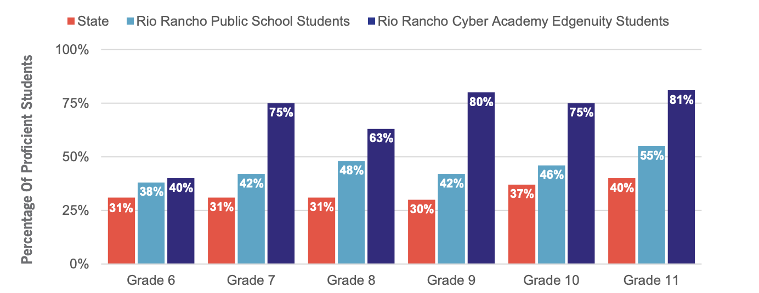

Success Virtual Learning Centers, Michigan (Level 4)
Located in Michigan, Success Virtual Learning Centers (SVLC) are designed to provide blended and virtual learning options to students who are struggling academically, at risk of dropping out, or who need an alternative to the traditional school setting. As part of a two-year study, Hypothesi LLC examined the reading, mathematics, and writing outcomes of Success Virtual Learning Center students who used Edgenuity during the 2013–2014 and 2014–2015 school years. Results showed that overall, students who used Edgenuity courses made statistically significant improvements in their reading, mathematics, and writing achievement as measured by the NWEA MAP Growth Mathematics, Language, and Reading tests and by the BASI Mathematics, Written Language, and Reading tests. For example, on the MAP Growth Math assessment, Edgenuity students demonstrated a statistically significant gain of 2.6 RIT points.

Figure 15. Success Virtual Learning Center Edgenuity Students, Grades 9–12
Performance on the NWEA MAP Growth Reading, Language, and Math Assessments, Fall 2014 to Spring 2015

Taos Academy Charter School, New Mexico (Level 4)
During the 2017–2018 school year, Taos Academy Charter School (TACS) used Edgenuity courses with 203 students in grades 5 to 12. Students arrive at TACS in 5th or 6th grade performing well below grade level in reading and mathematics. However, within a year of instruction, they performed well above their peers. In 2018, TACS students posted higher proficiency rates than the state average on the PARCC English language arts and mathematics tests. Additionally, more than double the number of 11th grade TACS students achieved proficiency on the 2018 SBA science exam compared to students in other schools across the state.

Figure 16. Taos Academy Students and Students Across New Mexico
Percentage Achieving Proficiency on PARCC ELA and Math Assessments and SBA Science Assessments, 2018

Utah Online, Utah (Level 4)
Utah Online uses Edgenuity Courseware with students who require immediate credit recovery, and students who are eager to take on additional coursework and graduate early. Over two academic years, Utah Online was restructured to include remediation for more than 120 students a year. After two years using Edgenuity, Utah Online students had a 12 percent increase in two-year graduation rates.

Figure 17. Utah Online Students
Graduation Rates, 2012 and 2014

Vertus High School, New York (Level 4)
Vertus Charter School (VCS) uses a blended learning model in which students learn in part through Edgenuity’s online courses and in part through in-person instruction and support. To assess program impact, fall and spring MAP Growth data were collected from 9th grade students enrolled in the school during the 2014–2015, 2015–2016, and 2016–2017 school years. Findings show that for three straight cohorts, students using Edgenuity online courses eliminated the mathematics achievement gap that had existed between VCS students and the national norm on the mathematics RIT scale. For example, in fall 2014, 2015, and 2016, 9th grade Edgenuity students were performing 6, 7, and 5 points, respectively, below the national norm. However, after using Edgenuity for two years, these students were performing 4, 2, and 3 points, respectively, above it.

Figure 18. Vertus Charter School Students, Grade 9
NWEA MAP Math Norm and Mean RIT Scores, by Cohort

Village Green Virtual Charter School, Rhode Island (Level 4)
Situated in the heart of Providence, Village Green Virtual Charter School (VGVCS) is the first public blended learning high school in Rhode Island. During the 2014–2015 academic year, 74 10th- and 11th-grade VGVCS students who took an Edgenuity English language arts courseand took the fall 2014 and spring 2015 NWEA MAP Growth Reading test; 83 10th- and 11th-grade VGVS students took an Edgenuity mathematics course and the fall 2014 and spring 2015 NWEA MAP
Growth Mathematics test. VGVCS students enrolled in Edgenuity demonstrated gains in reading and mathematics on the NWEA MAP Growth assessments from fall 2014 to spring 2015. These findings provide preliminary evidence that Edgenuity can have a positive impact on students’ academic achievement.

Figure 19. Village Green Virtual Charter School Edgenuity Students, Grades 10–11 (N = 74)
Performance on the NWEA MAP Growth Reading Assessment
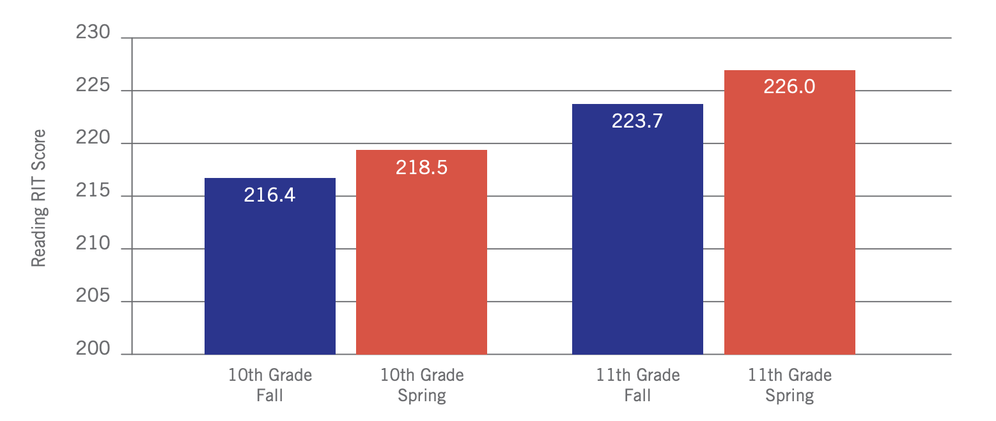
Figure 20. Village Green Virtual Charter School Edgenuity Students, Grades 10–11 (N = 83)
Performance on the NWEA MAP Growth Mathematics Assessment

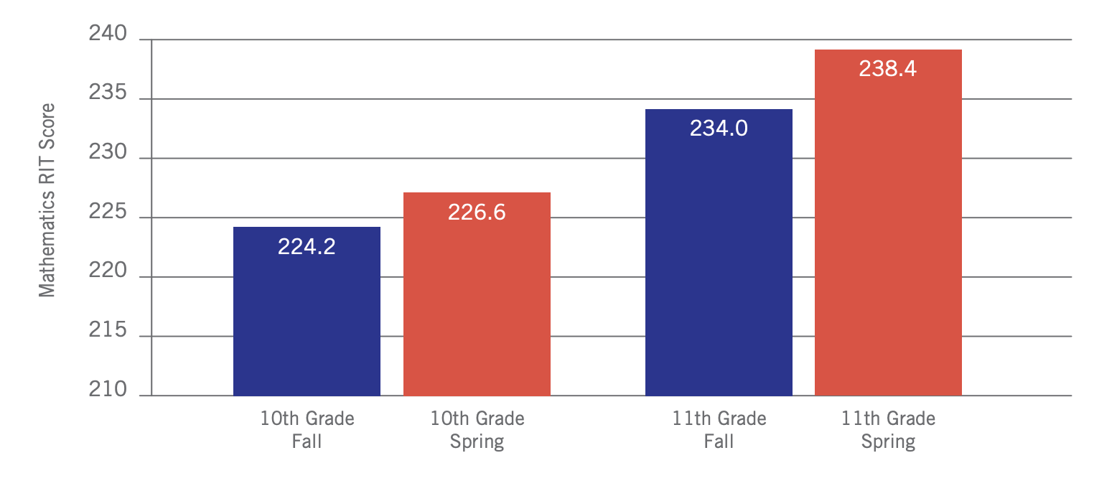
In 2015, 9th and 10th grade students took the Partnership for Assessment of Readiness for College and Careers (PARCC) English Language Arts/Literacy assessment, with results that were less than ideal: Only 16 percent of students scored proficient or above. After two years of a specially designed curriculum that involved unique, differentiated coursework for each student, students demonstrated impressive gains on the 2017 assessment. Proficiency rose to 40 percent, which was the single highest gain of any high school in Rhode Island.

Figure 21. Village Green Virtual Charter School Edgenuity Students, Grade 9
Percentage of Students Achieving Proficiency or Above on the PARCC English Language Arts/Literacy Assessment

Windsor High School, Connecticut (Level 4)
Windsor High School decided to implement Edgenuity courses with special education and school-phobic students. Special education and school-phobic students use Edgenuity courses five to ten hours a week as part of their foundational curriculum. Depending on the student’s individual education program, students may use Edgenuity’s math, language arts, or elective courses in the classroom or computer lab during a 60-minute period. After one year of implementing Edgenuity courses, the graduation rate of special education students in the program increased from 64 percent in 2014 to 86 percent in 2015.

Figure 22. Windsor High School Special Education Students
Graduation Rates, 2014 and 2015

